Hi sir,

I have followed these steps.

1.Installing Apache Tomcat server--- Tomcat 9.0

2.Installing Apache Maven--- apache-maven-3.8.8

3.opening cmd project folder path and entering command -- mvn clean package –DskipTests

After running command I am getting the message “BUILD SUCCESS”.

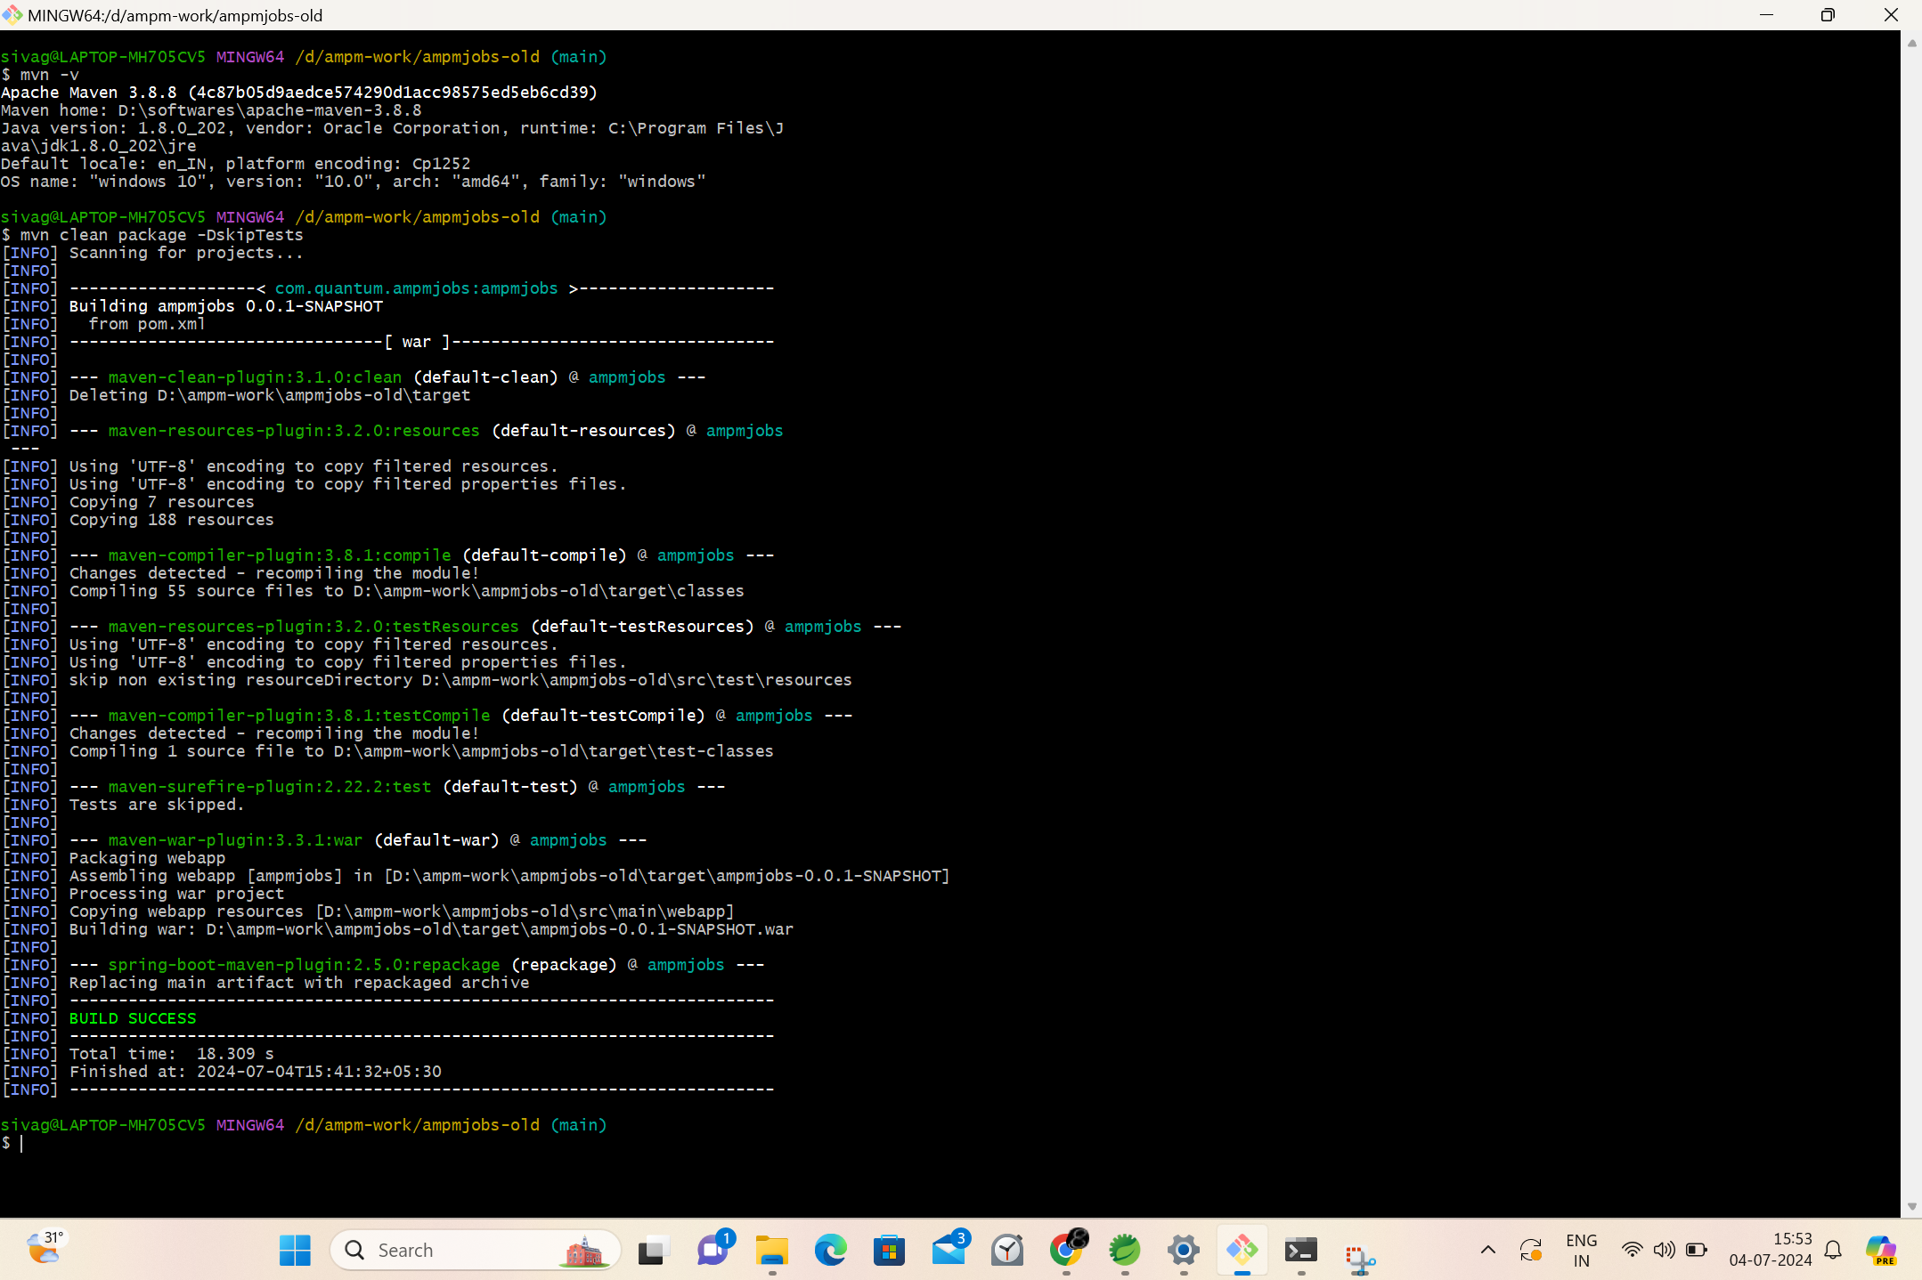

Build is success I am getting war file in target folder.

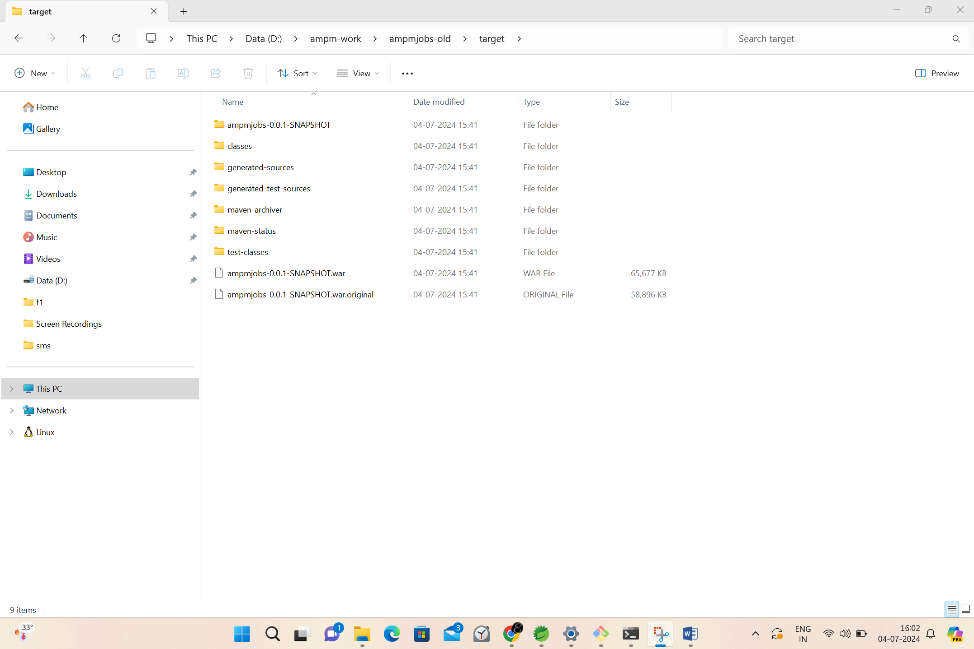

After I copied the war file and paste it into tomcat9.0 🡪webapps🡪ampmjobs.war

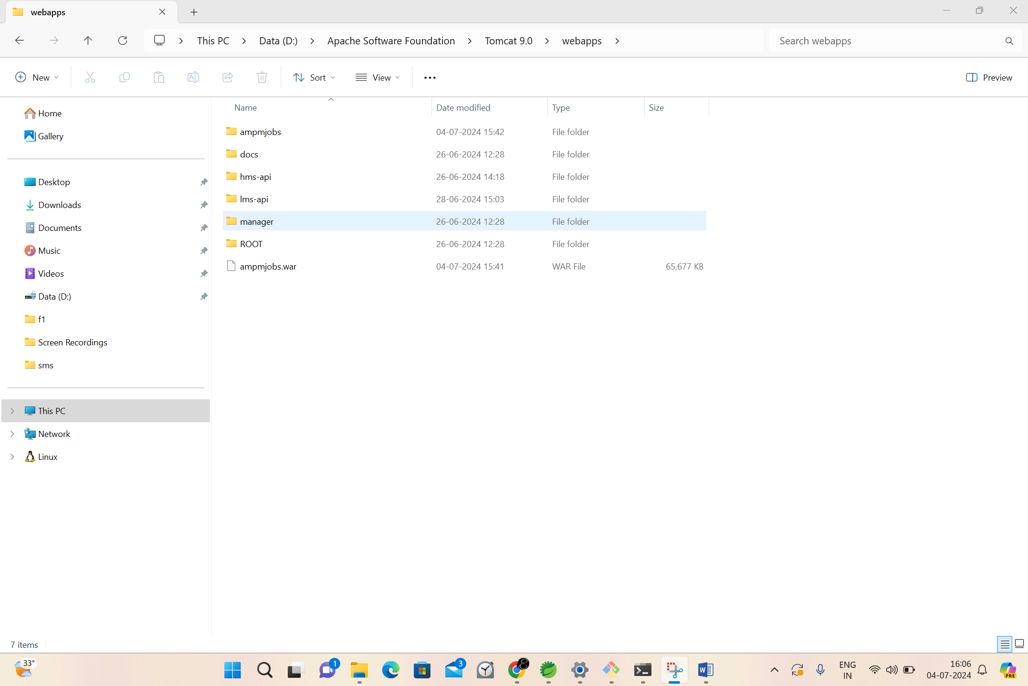

After that war file is pasted into server I am starting the server in bin folder startup.batch then server is starting in the command prompt.  
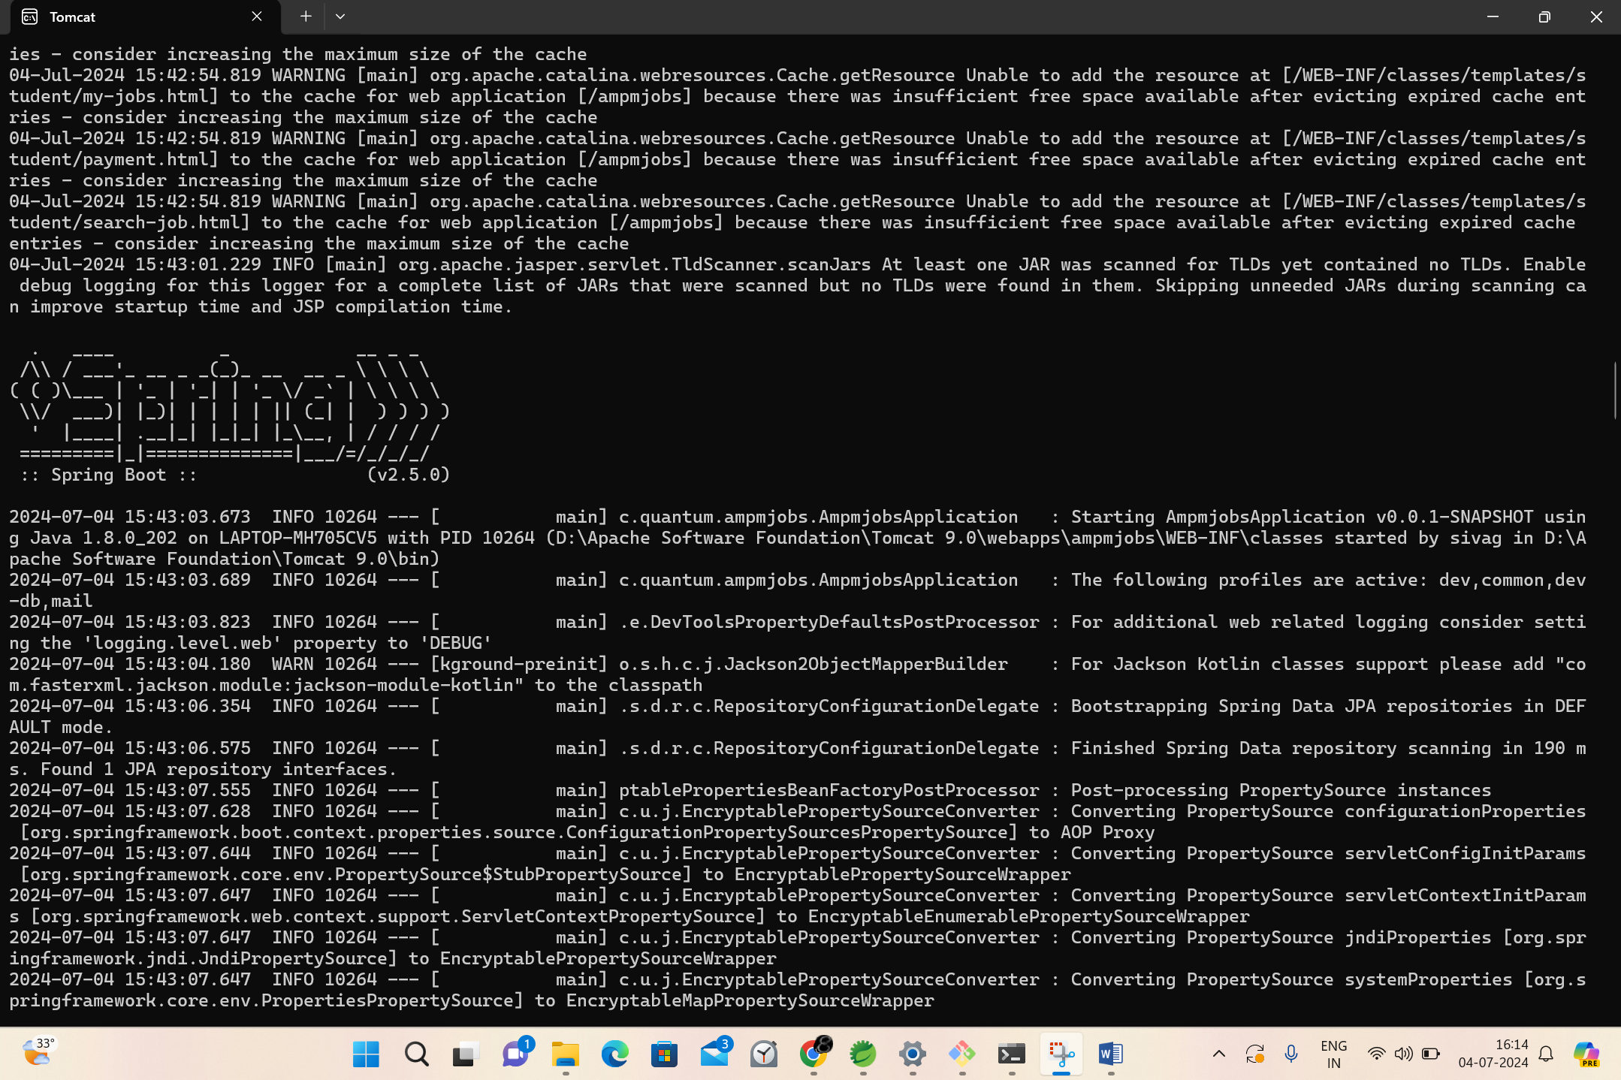

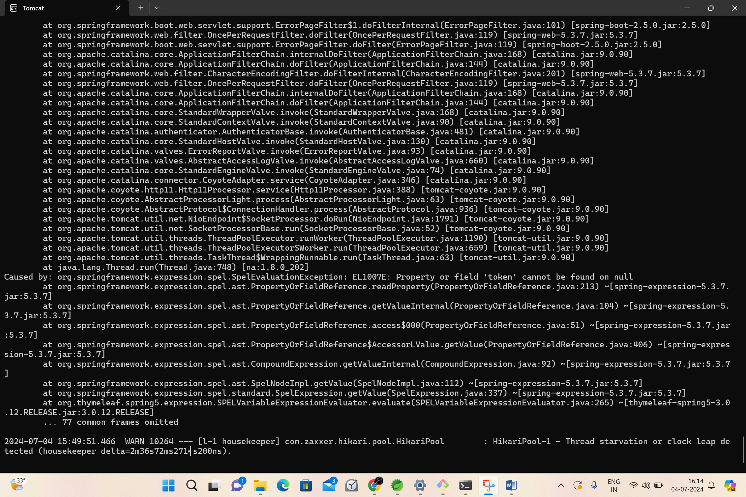

I am running the application in server at the port number <http://localhost:8080/ampmjobs/>

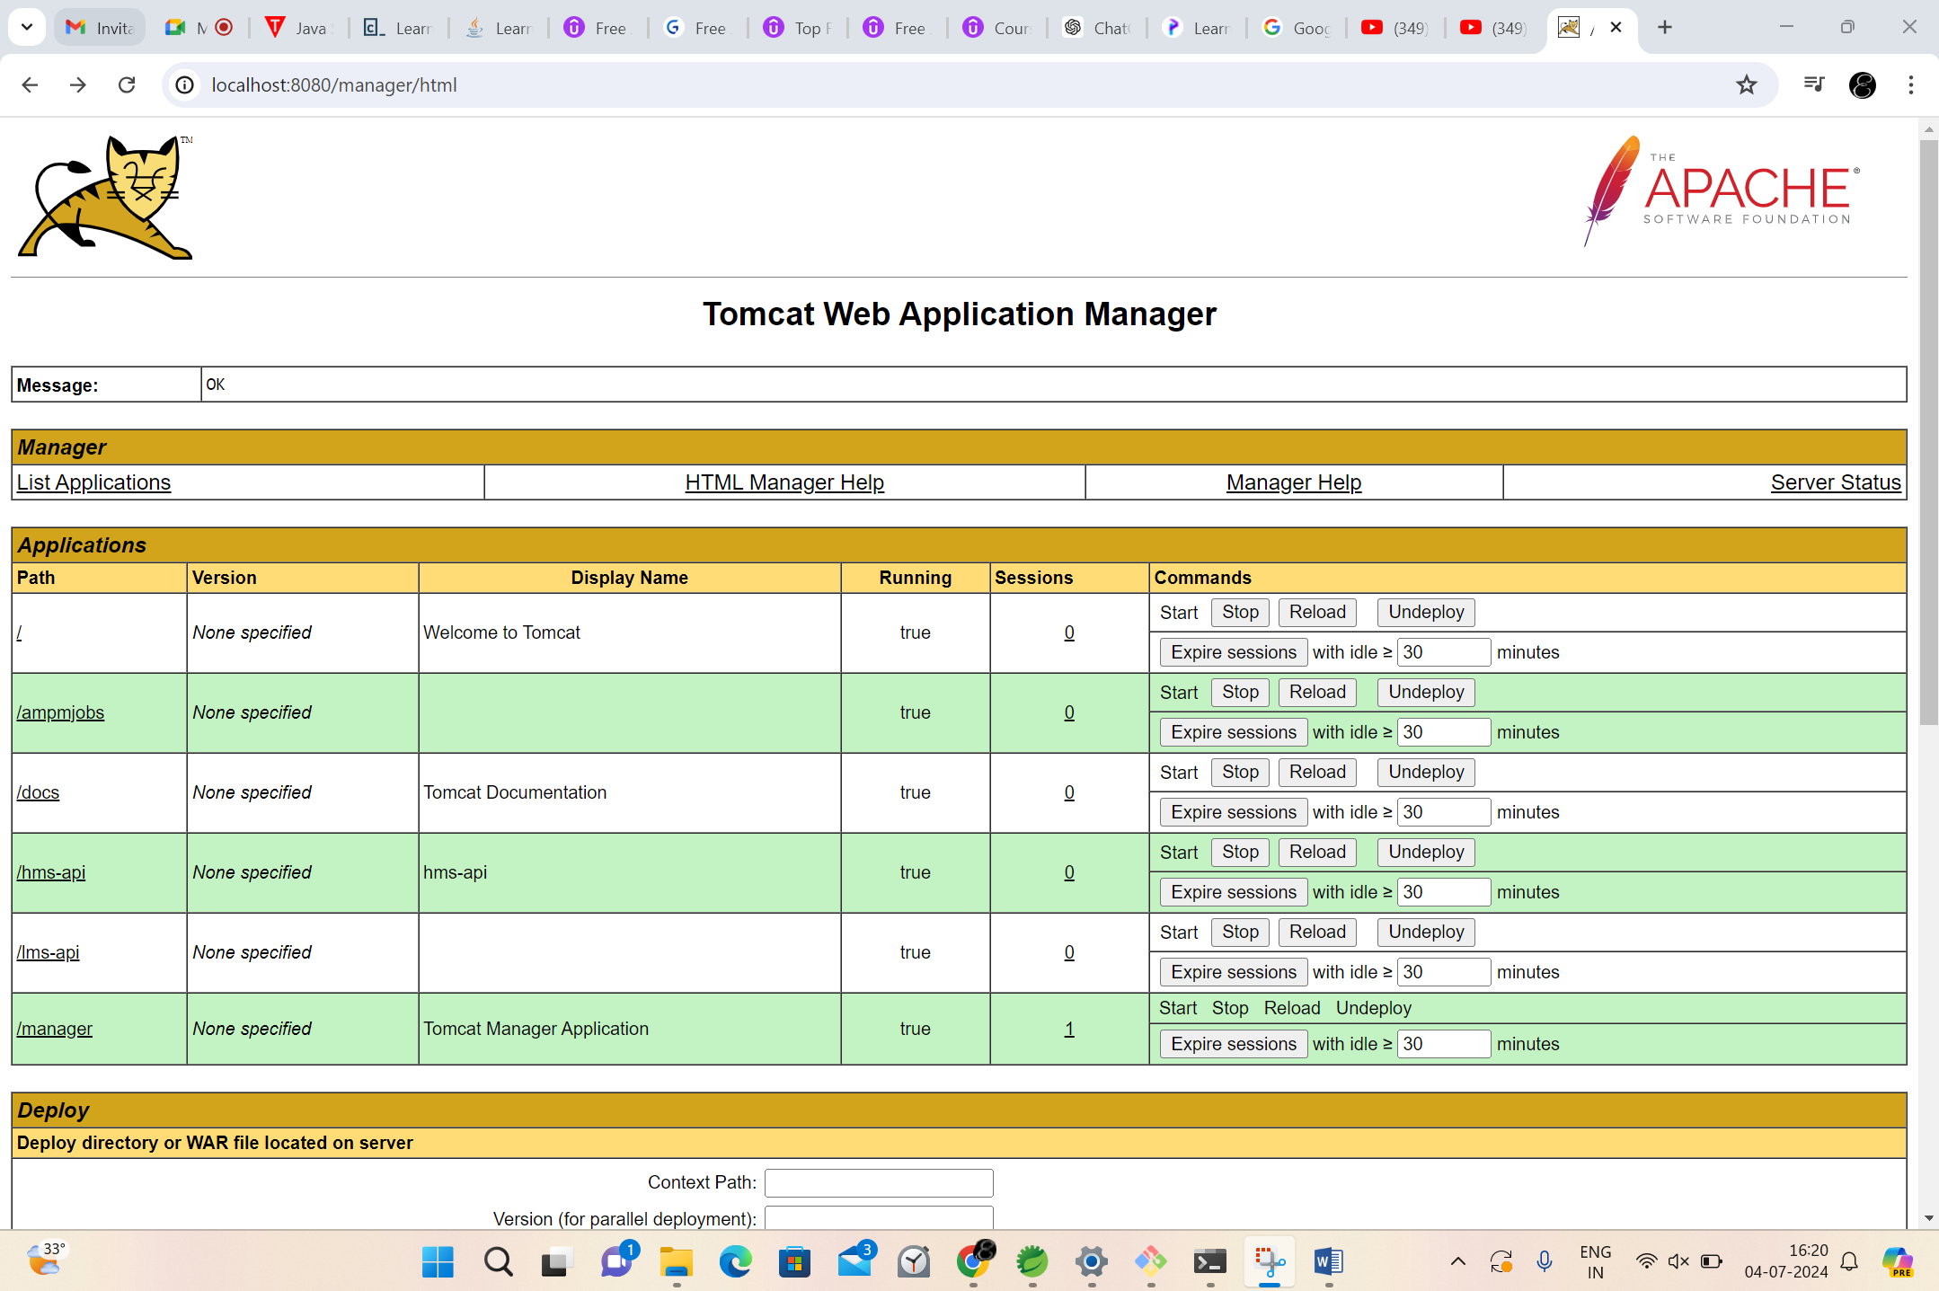

Now I am clicking in the ampmjobs the page is going to ampmjobs application  
  


Now I can see the application in server